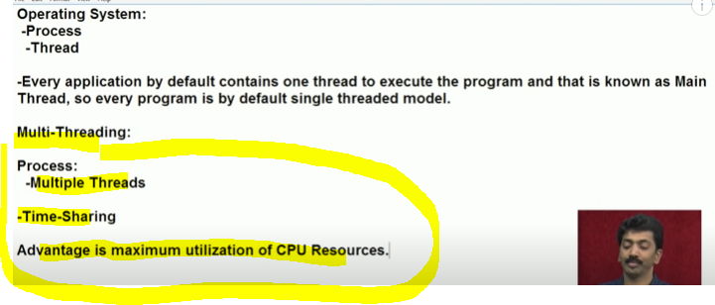

All Thread get equal time.

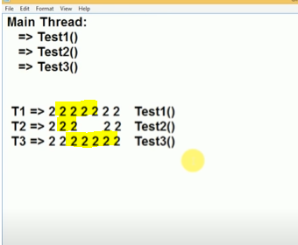

In Multi Threading we have 3 thread Thread T1 for execute Test1() and other accordingly.

Hear OS sharing the time between 3 Thread.

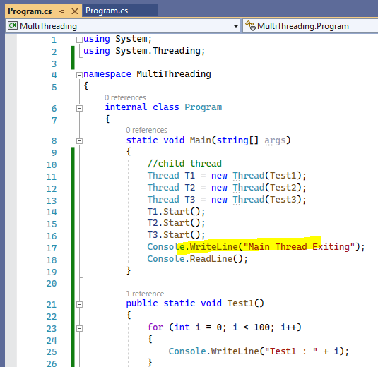

Run Output:

All 3 thread are sharing time:

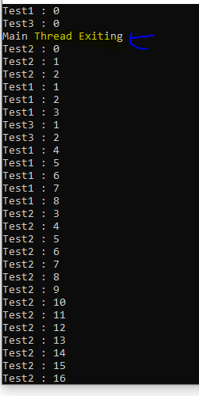 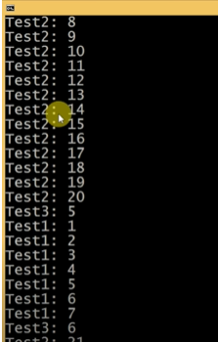

After finish Main Thread task main Thread existing.